# Bug 5 – Debugging Log

Hypothesis 1:

|  |  |
| --- | --- |
| Hypothesis | Dice.getRandom() not returning SPADE value |
| Prediction | The values of the dice roll will never show the SPADE face value |
| Experiment | Run game and observe |
| Observation | Dice rolls did produce all values except for SPADE and therefore proved prediction |
| Conclusion | Dice.getRandom() method must not be resulting in a SPADE result |

Bug Resolution:

To resolve the bug we need to remove the usage of RANDOM.nextInt(DIceValue.SPADE.ordinal() as it excludes SPADE value from being rolled thus rolling from 0 to N where N is exclusives applying this fix is demonstrated in the before and after screenshots:

Before:

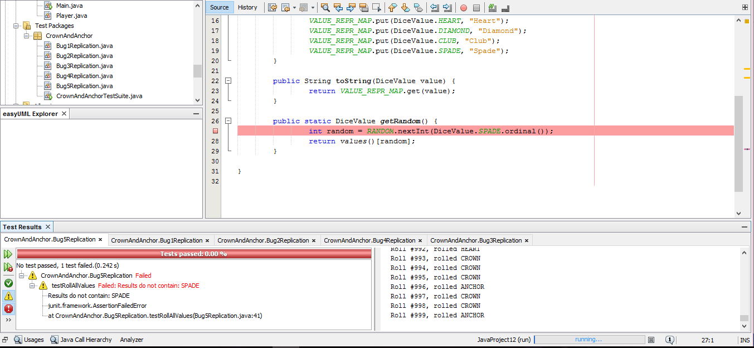

After: 